# Slope Chart

## Required Packages

* 1. XML
  2. Htmlwidgets
  3. Ggplot2
  4. plotly

## Generic steps for R installation

Note: Ensure you are installing the latest version of R and R studio.

Pre-requisites:

1. R integrated development environment:

If R is not installed, you will see:

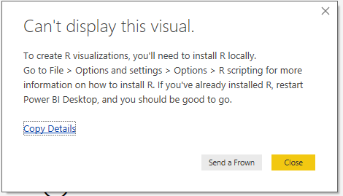

To download and install R: You can download and install **R** for free from the [Revolution Open download page](https://mran.revolutionanalytics.com/download/) or [CRAN Repository](https://cran.r-project.org/bin/windows/base/).

Once you are done installing R, **enable R visuals**. Select**File > Options and settings > Options**and in the **Options** page that appears, make sure your local R installation is specified in the **R Scripting** section of the **Options** window

1. R studio

For installation of R packages, R studio is required.

To install R studio: You can install your favorite R IDE, many of which are available for free, such as the [Revolution Open download page](https://mran.revolutionanalytics.com/download/), and the [CRAN Repository](https://cran.r-project.org/bin/windows/base/).

Check if R studio is installed properly.**Click on File > Options and settings > Options->R scripting.**

Once done installing R and R studio, Options should show the following

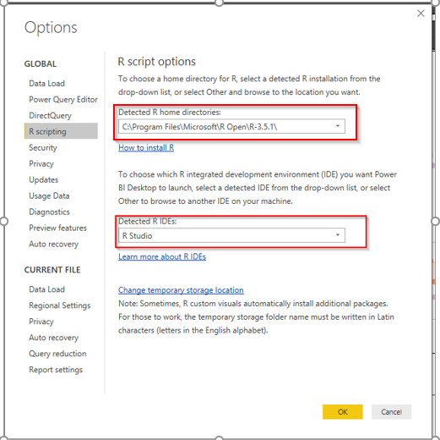

Steps:

1. Open the report of the visual, the following dialog will pop out. Click on Enable.

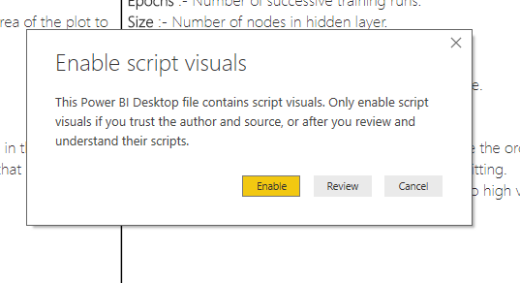

1. The following error can pop up if R is not installed or incorrect path to R is given or the required packages are not installed or some miscellaneous issue. To deep dive into the issue, click on see details

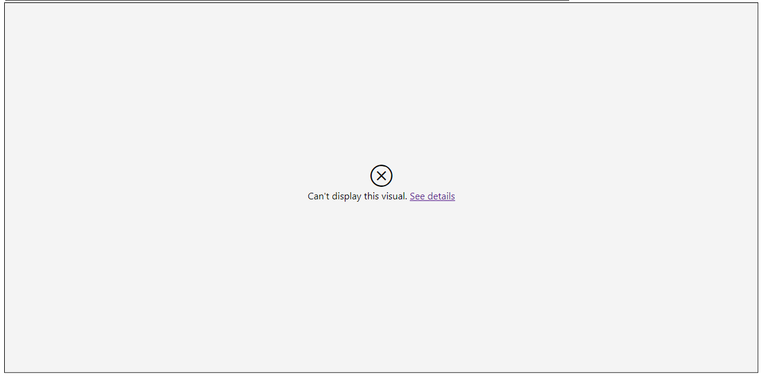

1. If **see details** shows the following:



This confirms that R is not installed. Install R by using the links mentioned above.

1. If **see details** shows the following:

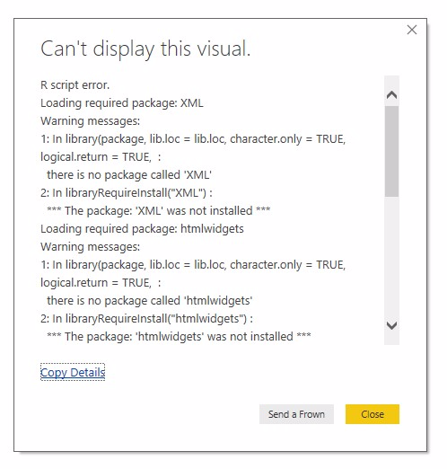

* 1. Click on the R script visual in Visualizations tab -> Click on Edit Script in external IDE present to the top right corner of R script editor console. The following should open:

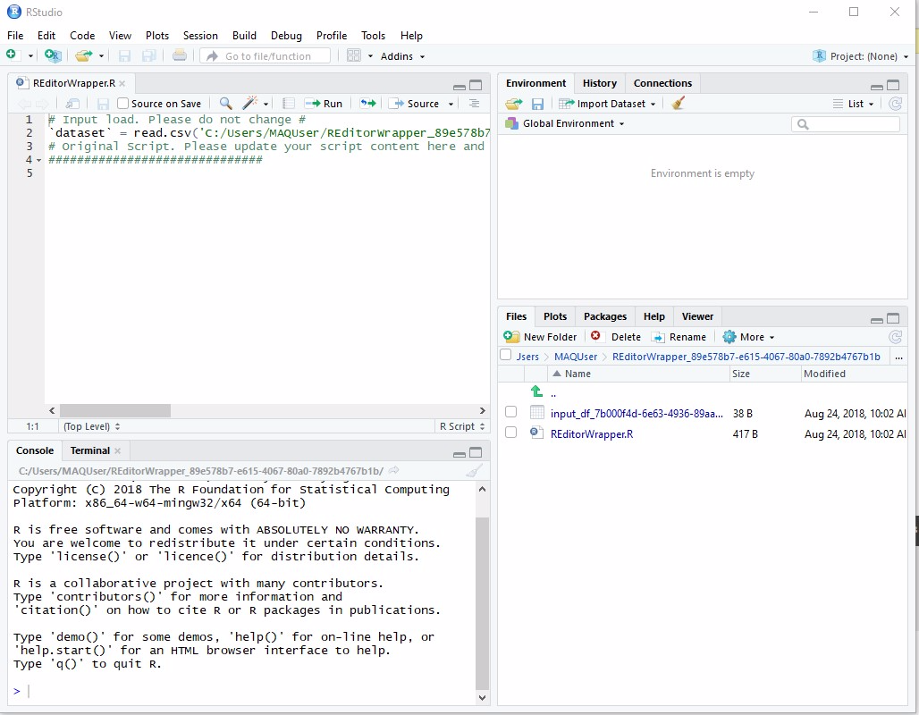

* 1. Click on the Packages tab->Click on Install

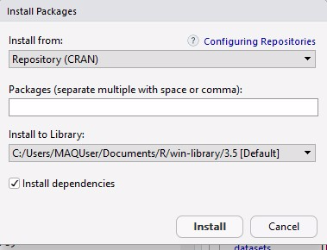

* 1. Specify the packages needed to be installed->Click on install.

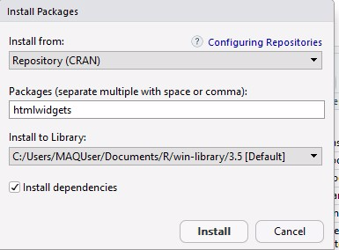

* 1. The packages will get installed.
  2. Follow step c to install all the packages.

1. Reload the visual.